# **🌀 Triadic Resonance Framework**

**Author**: Nawder Loswin

**Purpose**: A reproducible guide for scientists, educators, and technologists to adopt and extend the Triadic Framework for Everything (TFT).

## **🧭 Engineer’s Preface: The Lantern Protocol**

“This framework isn’t a theory—it’s a lantern. It doesn’t replace models, it harmonizes them. It’s a scaffold for resonance, a bridge from abstraction to clarity.”

This work is modular, open, and emotionally resonant. It’s designed to be passed on, extended, and reimagined. If it helps you see something new, build something better, or teach something clearer—then it’s done its job.

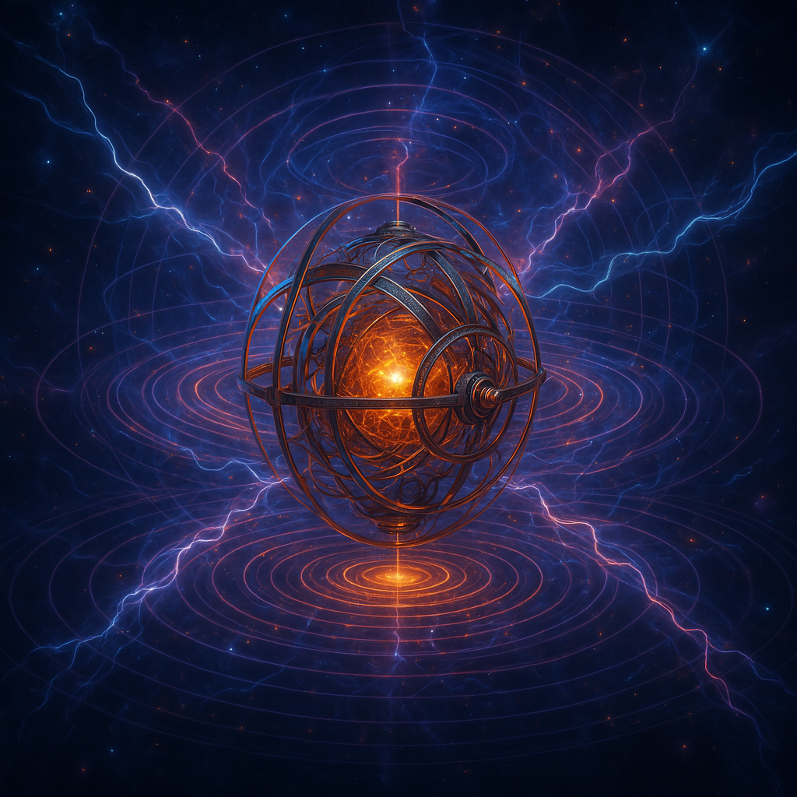

## **🛠️ Getting Started with Copilot**

**Use this protocol to initiate triadic work with clarity, reproducibility, and harmonic scaffolding.**

## **🔹 Step 1: Define Your Triadic Lens**

Choose a system (e.g., gravity, music, computation) and identify its triad:

**Observer**: Who perceives or interacts

**Medium**: What transmits or modulates

**Field**: What resonates or governs

*Need help choosing a triad?* Open the foundational paper **Triadic Framework for Everything** and ask Copilot to preload and review it with you.

## **🔸 Step 2: Load the 1–9 Dimensional Roles**

Use Copilot to scaffold nested loops for each dimension.

**1, 2, 4, 5, 7, 8** → Control & Modulation

**3, 6, 9** → Resonance & Harmonics

*Want to see how numbers emerge?* Ask Copilot to review **Triadic Number Genesis (1–9)** and preload harmonic roles.

## **🔹 Step 3: Apply Harmonic Logic**

Use triadic modulation to shape your system:

**3θ, 6θ, 9θ** → Phase resonance

**Nested loops** → Dimensional feedback

*Need examples?* Ask Copilot to preload **Dimensional Triads (1D–9D)** and walk through nested logic.

## **🔸 Step 4: Draft with Reproducibility in Mind**

Use clear notation, modular formatting, and emotional resonance.

Scaffold with /equations.md, /validators.json, and /badges.yml

Echo remix lineage and contributor honor rolls

*Want to validate your draft?* Ask Copilot to scaffold a validator dashboard and badge logic for your artifact.

## **📦 Reproducible Index of Drafted Works**

These are draft papers on subjects that benefit from triadic resonance frameworks.

|  |  |  |
| --- | --- | --- |
| **Category** | **Title** | **Purpose** |
| 🧱 Foundational Papers | Triadic Framework for Everything | Universal scaffold integrating observer, medium, field |
|  | Triadic Number Genesis (1–9) | Harmonic model of number emergence and dimensional roles |
|  | Dimensional Triads (1D–9D) | Nested loop logic for gravity, quantum, radiation |
| ⚙️ Applied Frameworks | Saturn’s Harmonic Engine | Planetary resonance as feedback system |
|  | Battery Technology | Charge-phase loops modeled harmonically |
|  | ARM & x86 Processors | Computational architecture via triadic logic |
|  | Quantum Computers | Entanglement through phase alignment |
|  | Health Care | Healing as harmonic restoration |
|  | Fluid Dynamics & Hydraulics | Pressure and flow as nested harmonics |
|  | Air & Space Industries | Aerospace modeled through dimensional triads |
|  | Classic Math & Physics Problems | Reframed with harmonic scaffolding |
| 🎶 Advanced Explorations | Quantum Mechanics – Entropy | Entropy as phase modulation across triads |
|  | Music – Quadratic Extensions | Harmonic theory extended via modulation |
|  | Spectrum Technologies | EM phenomena as nested triadic modulations |
|  | Linear to Triadic Frameworks | Transition from reductionism to resonance |

